

**Vanier College Computer Science Department**

**Deliverable 3**

**TEAM RED**

**Theodore Tsimiklis (2065694) Jiahui, Xia (2044092)**

**George Athanasatos (1951431) Andrei, Marinescu (1972210)**

**Client: Samer Assi**

**2022/02/22**

Table of Contents

EXECUTIVE OVERVIEW 2

Summary of the client 3

Business problem 4

Our way to resolve these problems: 4

Narrative description of system 5

Appendix 1 – Use cases: A system diagram for the entire information system 6

Appendix 2 – Filled out use case templates 7

Appendix 3 – UML diagrams 15

Appendix 4 – class diagram 17

Appendix 6 – Copies of forms 18

CONFIRMATION OF EACH TEAM MEMBER 19

References 20

# **EXECUTIVE OVERVIEW**

In this deliverable, we go over our plans for our web application. To do so, we create a system diagram of the entire information system, user cases based on the UML diagram, a UML diagram, and a class diagram to represent how our web application will function. We create these diagrams and details based on the demand our client has told us so that it may be as functional as possible. A detailed narrative description of our client, the business problem, the narrative description of the system, and the questionnaire that we previously shown in our second deliverable will be included.

We list the structure of how the application will work to achieve a concrete procedure when we start our implementation in the near future. The structure of the application needs confirmation that it can be implemented correctly and that they follow the given conditions that each should satisfy. For that purpose, we made sure to create 13 use cases to help us clarify our goals and for ample clarity.

# **Summary of the client**

Our client Samer is well equipped with computer knowledge. He has taken several computer classes, like an intro to coding class, and a few HTML classes. He grew up with computers at a young age, his understanding when it comes to computer programs/apps is good. He doesn’t necessarily know how to program from the ground up, but he knows how to design this web application in a way that makes it logically correct for us. His business is considered a B2C since it is between him (the business) and the customer (the consumer).

# **Business problem**

The painting business that we are working for has a couple of problems regarding the promotional aspect, customer experience, as well as the lack of demand for his services. There are multiple ways to resolve these issues and the application that we are meant to design for our client is designed to resolve at least the named ones.

## Our way to resolve these problems:

Since the customers are not aware of what our client has to offer to the fullest extent, he could just direct them to the site to provide better customer service. By doing so, if the customer is impressed by the end product, they can refer him through his site and acquire more customers which will higher up the demand for his skills and creativity

# **Narrative description of system**

The inventory is checked by the owner or by an employee who is qualified to do so, who then makes a list request that need to be fulfilled. The owner who obtains the list decides the date when to begin, what tools to bring as well as who would be necessary for the task.

The manager or the member responsible for the inventory must check the inventory and employee's availabilities and notes items that are running low as well as the employees that are able to work since they are both necessary during work. Next, the supplier is called and is given the list of required items. The manager is then provided with a transaction number for the order of the necessary items. Upon the arrival of the new stock, the inventory that is kept on an excel sheet must be updated. These steps are solely to have the items needed for the job, not to sell them.

The time and date that the employees must go to work must be written on an excel sheet along with terms and conditions of the work that needs to be accomplished. This excel document will be shared with all the employees so that they are aware of the requests as well as the time and date they would need to go and work. If one of the painting tools or substance is expired/broken, it is thrown out and replaced. If an employee is not professional or is not accomplishing his designated tasks, he will be warned and if done again let go of his position.

A significant part of running a painting business is making sure that you always have enough stock as well as employees. To manage this, the owner checks the inventory daily as well as the workers' availabilities. If the Inventory is well stocked and his employees are content, the manager will plan for the future of his business so that it may succeed. However, if the inventory is not well stocked and the employees are not happy, he must take note of any item or ingredient that is running low and contact his supplier to place an order as well as find a way to boost morale or in an extreme case to replace them. Once the order is received, the manager updates the inventory, and the cycle continues.

# **Appendix 1 – Use cases: A system diagram for the entire information system**

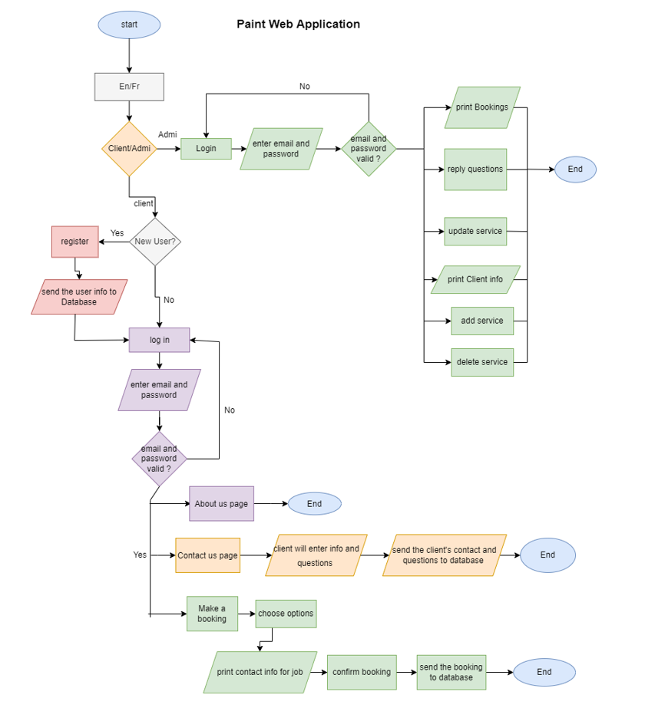

# **Appendix 2 – Filled out use case templates**

|  |  |  |  |
| --- | --- | --- | --- |
| **Use Case ID:** | **UC-En-Fr** | | |
| **Use Case Name:** | **EN/FR** | | |
| **Created By:** | **Team Red** | **Last Updated By:** | **Jiahui Xia** |
| **Date Created:** | **2022/03/01** | **Last Revision Daye:** | **2022/03/06** |
| **Actors:** | **Client (Primary) / Administration (Primary)** | | |
| **Description:** | **Choose the language of the Web Application** | | |
| **Trigger:** | **Client/Admin open the Web Application** | | |
| **Preconditions:** | **No** | | |
| **Postconditions:** | **Language is recorded in the system.** | | |
| **Normal Flow:** | **1. Choose the language**  **2. The selection will be recorded as the default language on next login if user has an account** | | |
| **Alternative Flow:** | **2a. The language will not be recorded** | | |
| **Exceptions:** | **1a. In step 1 of the normal flow, if user does not choose a language, English is default system language.** | | |
| **Includes:** | **No** | | |
| **Frequency of Use:** | **Option** | | |
| **Special Requirements:** | **Not applicable** | | |
| **Assumptions:** | **User use English or French** | | |
| **Notes and Issues:** | **No** | | |

|  |  |  |  |
| --- | --- | --- | --- |
| **Use Case ID:** | **UC-Login** | | |
| **Use Case Name:** | **Login** | | |
| **Created By:** | **Team Red** | **Last Updated By:** | **Jiahui Xia** |
| **Date Created:** | **2022/03/01** | **Last Revision Daye:** | **2022/03/06** |
| **Actors:** | **Client (Primary) / Admin(Primary)** | | |
| **Description:** | **Client/ Admin enter username and password to login his/her account** | | |
| **Trigger:** | **Client/Admin open the Web Application** | | |
| **Preconditions:** | **Client/Admin already has an account** | | |
| **Postconditions:** | **Client/Admin will go to the main page of the Application** | | |
| **Normal Flow:** | **1. User choose she/he is a client or admin**  **2. Enter username and password**  **2. Go to main page** | | |
| **Alternative Flow:** | **2a. Verify the username and password**  **If user is a client and the username is not existed, register an account** | | |
| **Exceptions:** | **2b. In step 2 of the normal flow, if username existed, but username and password is not matched**  **->loop step 1-2 until username and password is matched** | | |
| **Includes:** | **UC-Register** | | |
| **Frequency of Use:** | **On demand** | | |
| **Special Requirements:** | **Not applicable** | | |
| **Assumptions:** | **User did not forget his username and password** | | |
| **Notes and Issues:** | **No** | | |
| **Use Case ID:** | **UC-Register** | | |
| **Use Case Name:** | **Register** | | |
| **Created By:** | **Team Red** | **Last Updated By:** | **Jiahui Xia** |
| **Date Created:** | **2022/03/01** | **Last Revision Daye:** | **2022/03/06** |
| **Actors:** | **Client (Primary)** | | |
| **Description:** | **Client creates an account** | | |
| **Trigger:** | **Username is not existed when client login** | | |
| **Preconditions:** | **Username is not existed** | | |
| **Postconditions:** | **Client’s account information be recorded in system** | | |
| **Normal Flow:** | **1. Enter a username**  **2. Enter password**  **3. Confirm password**  **4. Enter First name and last name**  **5. Enter phone number** | | |
| **Alternative Flow:** | **1a. Check the username is unique**  **3a. Check that the password entered twice is the same**  **5a. Check phone number is valid** | | |
| **Exceptions:** | **Loop step 1-5 until all the information is valid and is not empty** | | |
| **Includes:** | **No** | | |
| **Frequency of Use:** | **On demand** | | |
| **Special Requirements:** | **Not applicate** | | |
| **Assumptions:** | **Client is able to fill out the registration form** | | |
| **Notes and Issues:** | **No** | | |

|  |  |  |  |
| --- | --- | --- | --- |
| **Use Case ID:** | **UC-AQ** | | |
| **Use Case Name:** | **Ask Questions** | | |
| **Created By:** | **Team Red** | **Last Updated By:** | **Theodore Tsimiklis** |
| **Date Created:** | **2022/03/03** | **Last Revision Date:** | **2022/03/06** |
| **Actors:** | **Client(primary) / admin (primary)** | | |
| **Description:** | **Client asked questions** | | |
| **Trigger:** | **Enter contact page** | | |
| **Preconditions:** | **User fills out questionnaire form** | | |
| **Postconditions:** | 1. **Question gets sent to admin via email** 2. **User waits for response from admin through email** | | |
| **Normal Flow:** | 1. **Admin receives question through email** 2. **Admin contacts user who sent question via email** 3. **Admin and user try to resolve any problems/questions user may have** 4. **Loop back 1-3 anytime admin gets contacted** | | |
| **Alternative Flow:** | **Follow steps 1-4 from normal flow** | | |
| **Exceptions:** | **If user does not respond after a certain amount of time close question** | | |
| **Includes:** | **UC-CM** | | |
| **Frequency of Use:** | **Whenever user has a question** | | |
| **Special Requirements:** | **Not applicable** | | |
| **Assumptions:** | **User can fill out the contact form** | | |
| **Notes and Issues:** | **Not applicable** | | |
| **Use Case ID:** | **UC-CM** | | |
| **Use Case Name:** | **Confirm** | | |
| **Created By:** | **Team Red** | **Last Updated By:** | **Theodore Tsimiklis** |
| **Date Created:** | **2022/03/06** | **Last Revision Date:** | **2022/03/06** |
| **Actors:** | **Admin (Primary)** | | |
| **Description:** | **To confirm question** | | |
| **Trigger:** | **When user is about to submit question** | | |
| **Preconditions:** | **Questionnaire must be filled** | | |
| **Postconditions:** | 1. **Fill out questionnaire** 2. **Message prompt pops up** | | |
| **Normal Flow:** | 1. **Fill out questionnaire** 2. **Fill out name last name** 3. **Add email** 4. **Add phone number as secondary contact** 5. **Write question** 6. **Submit question** 7. **Message prompt pops up** 8. **Question is either sent or not** | | |
| **Alternative Flow:** | **Follow steps 1-3 in normal flow** | | |
| **Exceptions:** | **User can say no when message prompt pops up** | | |
| **Includes:** | **Not applicable** | | |
| **Frequency of Use:** | **Whenever questionnaire is filled** | | |
| **Special Requirements:** | **Not applicable** | | |
| **Assumptions:** | **User can fill out questionnaire** | | |
| **Notes and Issues:** | **Not applicable** | | |

|  |  |  |  |
| --- | --- | --- | --- |
| **Use Case ID:** | **UC-RY** | | |
| **Use Case Name:** | **Reply** | | |
| **Created By:** | **Team Red** | **Last Updated By:** | **Theodore Tsimiklis** |
| **Date Created:** | **2022/03/06** | **Last Revision Date:** | **2022/03/06** |
| **Actors:** | **Admin (primary)/User (Primary)** | | |
| **Description:** | **Replies to questions from users that were sent via email** | | |
| **Trigger:** | **If a question was asked from a user and the user is waiting for a response** | | |
| **Preconditions:** | **Wait for user to contact admin through email** | | |
| **Postconditions:** | 1. **User sends questions via email from the questionnaire** 2. **Admin responds to question when question is received from email** | | |
| **Normal Flow:** | 1. **Admin receives question through email** 2. **Admin contacts user who sent question via email** 3. **Admin and user try to resolve any problems/questions user may have** 4. **Loop back 1-3 anytime admin gets contacted** | | |
| **Alternative Flow:** | **Follow steps 1-4 from normal flow** | | |
| **Exceptions:** | **Responses might be delayed if multiple questions are being asked from different users** | | |
| **Includes:** | **Not Applicable** | | |
| **Frequency of Use:** | **Whenever a question is asked** | | |
| **Special Requirements:** | **Not applicable** | | |
| **Assumptions:** | **Admin knows how to correctly write back a reply to a message in a professional manner** | | |
| **Notes and Issues:** | **Not applicable** | | |

|  |  |  |  |
| --- | --- | --- | --- |
| **Use Case ID:** | **UC-BG** | | |
| **Use Case Name:** | **Booking** | | |
| **Created By:** | **Team Red** | **Last Updated By:** | **Theodore Tsimiklis** |
| **Date Created:** | **2022/03/06** | **Last Revision Date:** | **2022/03/06** |
| **Actors:** | **Users (primary)** | | |
| **Description:** | **To book an appointment** | | |
| **Trigger:** | **When user goes to booking page** | | |
| **Preconditions:** | **User fills out booking form** | | |
| **Postconditions:** | 1. **User fills out form** 2. **Form get sent to admin and is all setup for an appointment** | | |
| **Normal Flow:** | 1. **Fill out form** 2. **Pick a date to schedule** 3. **Click the book button to set appointment** | | |
| **Alternative Flow:** | **Follow steps 1-3 in Normal flow** | | |
| **Exceptions:** | **No exceptions everything in the form must be filled out** | | |
| **Includes:** | **UC-OP** | | |
| **Frequency of Use:** | **On-demand** | | |
| **Special Requirements:** | **Not applicable** | | |
| **Assumptions:** | **User knows how to fill out a form** | | |
| **Notes and Issues:** | **Not applicable** | | |

|  |  |  |  |
| --- | --- | --- | --- |
| **Use Case ID:** | **UC-GQ** | | |
| **Use Case Name:** | **Get Question** | | |
| **Created By:** | **Team Red** | **Last Updated By:** | **George Athanasatos** |
| **Date Created:** | **2022/03/06** | **Last Revision date:** | **2022** |
| **Actors:** | **admin (Primary)** | | |
| **Description:** | **Admin receives a question from the user** | | |
| **Trigger:** | **When admin receives a question, the admin will send an answer out.** | | |
| **Preconditions:** | **Admin / database gets the question** | | |
| **Postconditions:** | **1. Admin revises the question**  **2. thinks of an answers** | | |
| **Normal Flow:** | **1. Receive question from client by email**  **2. Read the Question**  **3. sends the answer to reply by email** | | |
| **Alternative Flow:** | **Follow steps 1-3 in normal flow** | | |
| **Exceptions:** | **There are no exceptions. Client must ask a proper question to get answered.** | | |
| **Includes:** | **Not Applicable** | | |
| **Frequency of Use:** | **Whenever a question is received** | | |
| **Special Requirements:** | **Not applicable** | | |
| **Assumptions:** | **Admin can receive the question** | | |
| **Notes and Issues:** | **Not Applicable** | | |

|  |  |  |  |
| --- | --- | --- | --- |
| **Use Case ID:** | **UC-OP** | | |
| **Use Case Name:** | **Options** | | |
| **Created By:** | **Team Red** | **Last Updated by:** | **George Athanasatos** |
| **Date Created:** | **2022/03/06** | **Last revised:** | **2022/03/06** |
| **Actors:** | **Client (Primary)** | | |
| **Description:** | **Client can book and get the contact info for the job's options.** | | |
| **Trigger:** | **When the client selects to book or contact info, it will see the different options to choose from.** | | |
| **Preconditions:** | **Client looks at its options** | | |
| **Postconditions:** | **1. Client clicks booking**  **2. Client can then select their options** | | |
| **Normal Flow:** | **1. Go into the booking section**  **2. select options for booking**  **3. get the contact info**  **4. selection the options for contact info** | | |
| **Alternative Flow:** | **Same as normal flow** | | |
| **Exceptions:** | **Not Applicable** | | |
| **Includes:** | **Booking and Get contact info** | | |
| **Frequency of Use:** | **Whenever looking at booking section** | | |
| **Special Requirements:** | **Have to go through booking and contact info to select options.** | | |
| **Assumptions:** | **Client knows what options they want.** | | |
| **Notes and Issues:** | **Not Applicable** | | |
| **Use Case ID:** | **UC-GC** | | |
| **Use Case Name:** | **Get Clients info** | | |
| **Created By:** | **Team Red** | **Last Updated By:** | **George Athanasatos** |
| **Date Created:** | **2022/03/06** | **Last revised:** | **2022/03/06** |
| **Actors:** | **Admin (Primary) / Database (Primary)** | | |
| **Description:** | **Admin will get the clients info, once the client inputs it.** | | |
| **Trigger:** | **When the client inputs their contact info, the admin will then be able to see it.** | | |
| **Preconditions:** | **Client inputs their contact info.** | | |
| **Postconditions:** | **1. Client goes to booking after login**  **2. Client sets up their info.** | | |
| **Normal Flow:** | **1. Client creates their account**  **2. Client logins in**  **3. Client goes to book**  **4. Client sets their info** | | |
| **Alternative Flow:** | **Not Applicable** | | |
| **Exceptions:** | **Not Applicable** | | |
| **Includes:** | **Booking** | | |
| **Frequency of Use:** | **Whenever the client input’s their info.** | | |
| **Special Requirements:** | **Not Applicable** | | |
| **Assumptions:** | **Client knows how to put in their info.** | | |
| **Notes and Issues:** | **Not Applicable** | | |

|  |  |  |  |
| --- | --- | --- | --- |
| **Use Case ID:** | **UC-ES** | | |
| **Use Case Name:** | **Edit Service** | | |
| **Created By:** | **Team Red** | **Last Updated By:** | **George Athanasatos** |
| **Date Created:** | **2022/03/06** | **Last revised:** | **2022/03/06** |
| **Actors:** | **Admin (Primary)** | | |
| **Description:** | **Admin is able to edit the web application and selections made.** | | |
| **Trigger:** | **When admin wants to edit his services** | | |
| **Preconditions:** | **Admin is able to edit the web application** | | |
| **Postconditions:** | **1. Admin logins**  **2. Admins edits his services** | | |
| **Normal Flow:** | **1. Admin Logs in**  **2. Admin goes to booking**  **3. Admin clicks edit service**  **4. Admin edits his services**  **5. Admin edits painting service**  **6. Admin edits sanding service**  **7. Admin edits staining service** | | |
| **Alternative Flow:** | **Not Applicable** | | |
| **Exceptions:** | **Not Applicable** | | |
| **Includes:** | **Booking** | | |
| **Frequency of Use:** | **On Demand** | | |
| **Special Requirements:** | **Not Applicable** | | |
| **Assumptions:** | **Admin knows how to edit services** | | |
| **Notes and Issues:** | **Not Applicable** | | |

|  |  |  |  |
| --- | --- | --- | --- |
| **Use Case ID:** | **UC-MS** | | |
| **Use Case Name:** | **Get Contact Info for job** | | |
| **Created By:** | **Team Red** | **Last Updated By:** | **Andrei Marinescu** |
| **Date Created:** | **2022/03/05** | **Last revised:** | **2022/03/06** |
| **Actors:** | **Client(Primary)** | | |
| **Description:** | **Share contact information for the job.** | | |
| **Trigger:** | **Once the option section is fulfilled and confirmed** | | |
| **Preconditions:** | **If client filled up the option section** | | |
| **Postconditions:** | **Client will go to the confirm booking page** | | |
| **Normal Flow:** | 1. **Client enters a street address** 2. **Client enters a city** 3. **Client enters a state/province** 4. **Client enters a country** 5. **Client enters a postal code** 6. **Client confirms this page** | | |
| **Alternative Flow:** | **Follow steps 1-6 from normal flow** | | |
| **Exceptions:** | **Loop step 1-6 until all the information is valid and is not empty** | | |
| **Includes:** | **UC-OP** | | |
| **Frequency of Use:** | **Whenever questionnaire is filled** | | |
| **Special Requirements:** | **Not applicable** | | |
| **Assumptions:** | **Client is able to fill out his/her address information** | | |
| **Notes and Issues:** | **Not applicable** | | |

|  |  |  |  |
| --- | --- | --- | --- |
| **Use Case ID:** | **UC-KS** | | |
| **Use Case Name:** | **Confirm Booking** | | |
| **Created By:** | **Team Red** | **Last Updated By:** | **Andrei Marinescu** |
| **Date Created:** | **2022/03/05** | **Last revised:** | **2022/03/06** |
| **Actors:** | **Client (Primary)** | | |
| **Description:** | **Confirm that an order is placed** | | |
| **Trigger:** | **Once the contact information is inserted and confirmed** | | |
| **Preconditions:** | **If client filled up the address section** | | |
| **Postconditions:** | **Client will go to the main page of the application** | | |
| **Normal Flow:** | 1. **Client reads the booking information** 2. **Confirmation of booking** | | |
| **Alternative Flow:** | **Follow steps 1-2 from normal flow** | | |
| **Exceptions:** | **If the client is not content with the order, he can go back to the main page without confirming the order.** | | |
| **Includes:** | **UC-MS** | | |
| **Frequency of Use:** | **Whenever an order is processed** | | |
| **Special Requirements:** | **Not applicable** | | |
| **Assumptions:** | **If client is certain of her order to confirm it** | | |
| **Notes and Issues:** | **Not applicable** | | |

# **Appendix 3 – UML diagrams**

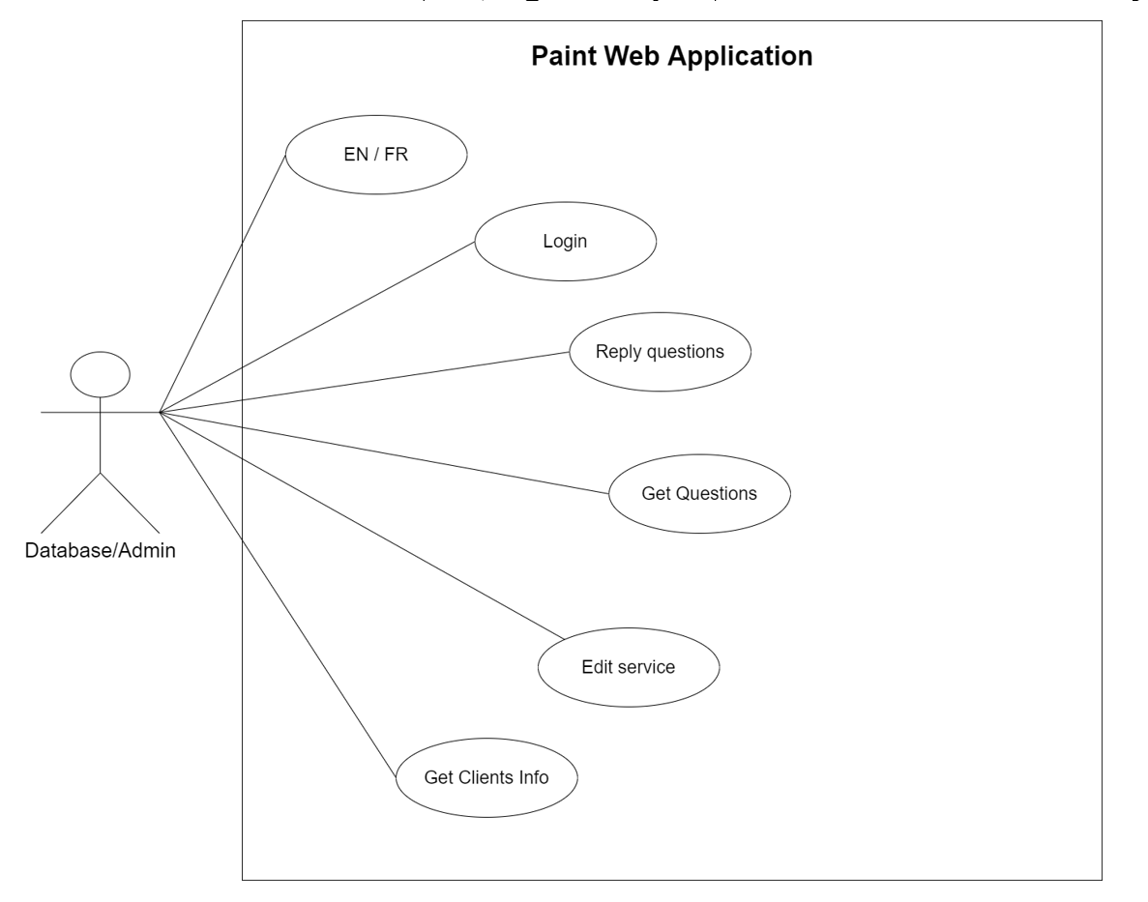

# **Appendix 4 – class diagram**

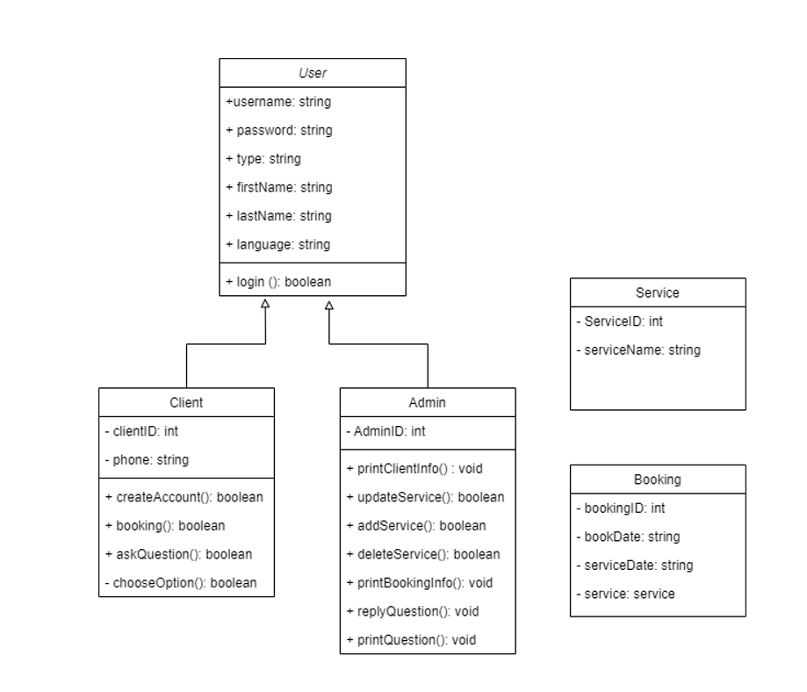

# **Appendix 6 – Copies of forms**

**1. Why do you want a new web application for your business?**

I believe that by having the business online, booking estimates which eventually leads to the signature of contracts can be simplified and done through the site in a much more efficient manner.

**2. Describe your business in a few sentences.**

My company’s main source of revenue comes from a service which we provide. Our main services include Painting, Staining and Sanding.

**3. What specific features do you want on the site?**

I want clients to be able to book their own estimates based on the opening that are provided and also be able to provide basic information about them, their projects and their budget.

**4. What will your clients do on your website?**

They will look at my portfolio of work that I already completed, book estimates on their own and use the information provided to contact me and interact with the business.

**5. What image, look or feel do you want the web application to portray. (what colors / design, or an example of a web application to base off of).**

I want it to be simple looking and not have too much clutter.

I want it to also somewhat have a modern style to it but with a creative touch because painting does include creativity to a degree.

**6. Where is your business located?**

My business is located in Dorval/Lachine

**7. Do you have a current web application for your business?**

Nope, I do not.

# **CONFIRMATION OF EACH TEAM MEMBER**

**Signature: **

**Printed Name: Theodore Tsimiklis**  **Date: 2022-03-08**

**Signature:** 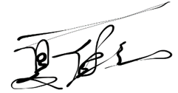

**Printed Name: Jiahui Xia** **Date: 2022-03-08**

**Signature:** 

**Printed Name: George Athanasatos** **Date: 2022-03-08**

**Signature:** 

**Printed Name: Andrei Marinescu** **Date: 2022-03-08**

# References

*30 examples of Business Problems*. Simplicable. (n.d.). Retrieved February 17, 2022, from <https://simplicable.com/new/business-problems>